BRIGGS MODELS DOFASCO TRUCK CONVERSION KIT

This is a re-tooled release of the DOFASCO truck conversion kit with major improvements. The trucks are intended to fit underneath the Atlas ALCO C-630 and utilize the original gears. The gearboxes are now a one piece polyurethane resin casting, and the bearing plates and pickups are etched in brass. The sideframes attach to the outside of the gearbox. As completed the kit provides the correct Dofasco six-axle trucks with equal axle spacing and a shorter wheelbase of 134 inches for the Canadian C-630M and M-630 locomotives. It is suitable for use with the Atlas ready-to-run Canadian C-630s or with the new M-630 kit (see below). Retail price is $39.95 CAD. Production is limited to 100 kits.

What Is In The Kit:

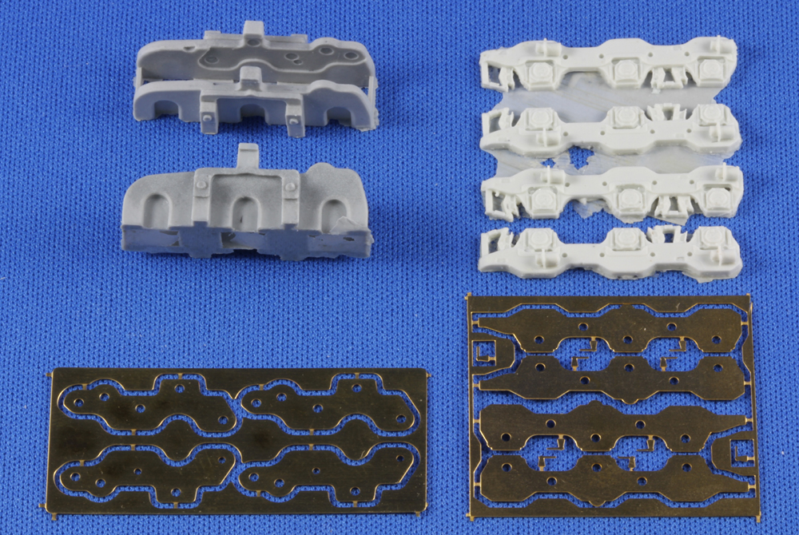

BRIGGS MODELS DOFASCO TRUCK CONVERSION KIT

Finished Kit:

