BRIGGS MODELS ALCO C-425 CONVERSION KIT

This is a re-release of the ALCO C-425 body shell and detail kit without any changes from the previous issue. The shell is intended to fit onto the Life-Like ALCO C-424 mechanism and mates with the original deck, handrails, cab and radiator top. The kit comprises a one piece body shell cast in polyurethane resin and a sprue of resin detail parts including footboard pilots, two types of nose ditch lights, vertical headlight, two types of inertial air filters, a bell and bracket. As completed the kit yields an accurate representation of a Phase I ALCO C-425 as delivered to the Erie Lackawanna Railroad (2451-2462) and later sold to the British Columbia Railway (801-812). Retail price is $49.95 CAD and production is limited to 25 kits.

What Is In The Kit:

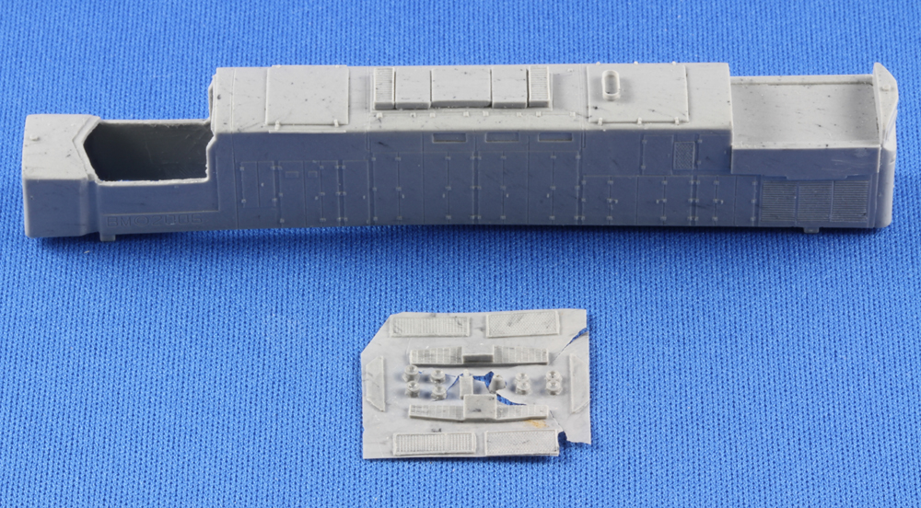

BRIGGS MODELS ALCO C-425 CONVERSION KIT

Finished Kit:

